**AWS EC2 instance setup**

1. Add bash commands

***#!/bin/bash***

***sudo yum update -y***

***sudo yum install -y httpd***

***sudo systemctl start httpd***

***sudo systemctl enable httpd***

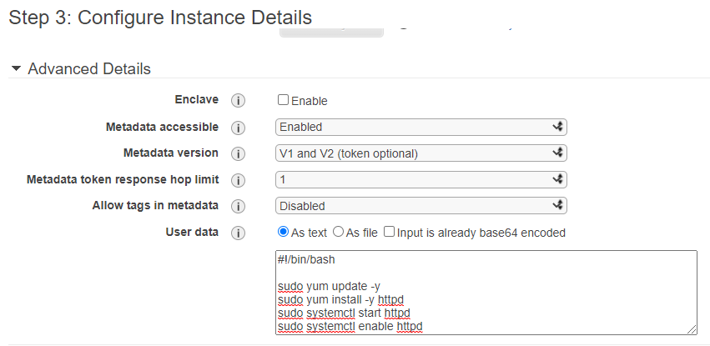

1. Added Custom TCP rule for security group with port ***5000*** and input ***0.0.0.0/0, ::/0***

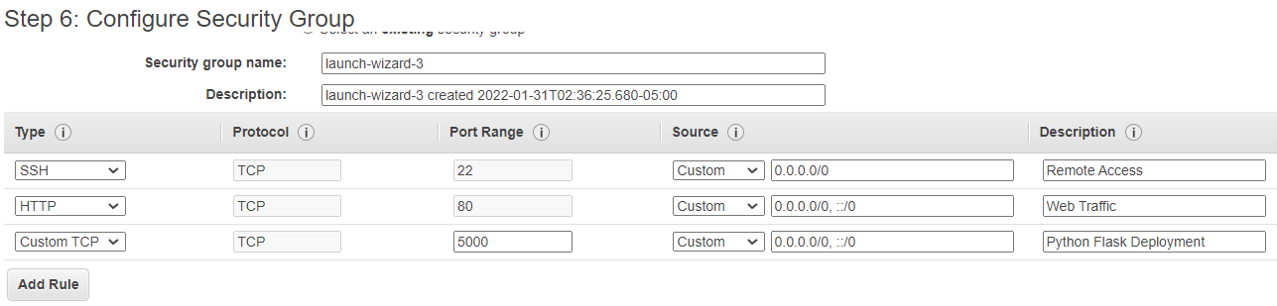

1. Instance launched and running

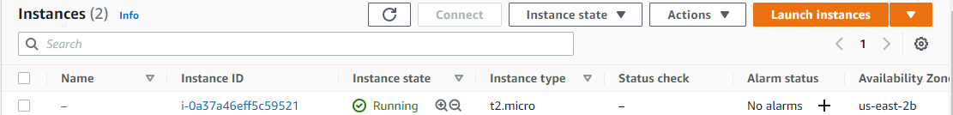

1. Check instance details

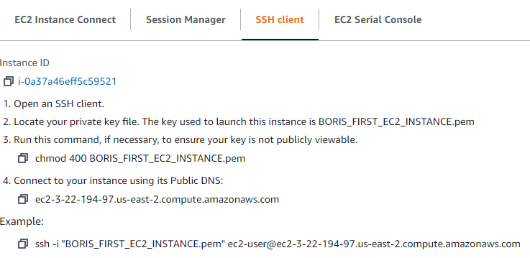

**Putty Setup**

1. Generate Putty compatible authentication key (.ppk)



1. Connect to EC2 instance from Putty using key

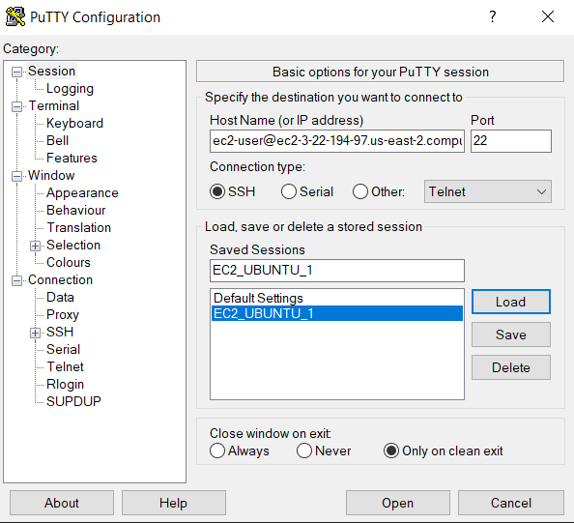

1. Check if our web server was installed properly and started.

***systemctl status httpd***

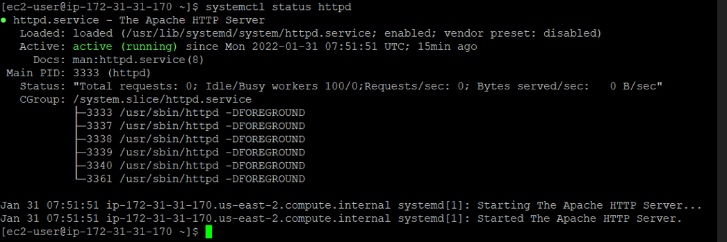

**Navigate to HTML directory**

1. Go where the HTML will be stored for our Web Server

***cd /var/www/html***

**Install Python**

1. Run below to install and then check python version

***sudo yum install python37***

***python3 –version***

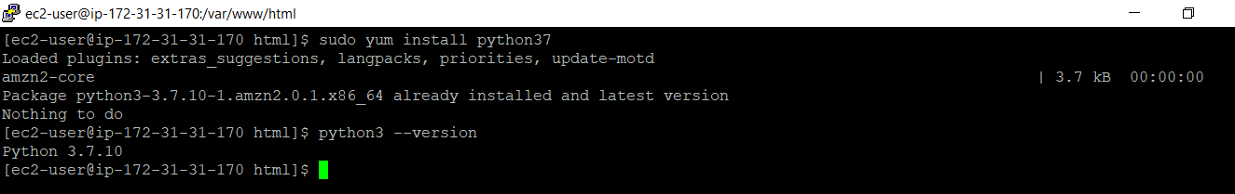

**Download and install PIP**

1. Download PIP from a repository

***sudo curl -O***[***https://bootstrap.pypa.io/get-pip.py***](https://bootstrap.pypa.io/get-pip.py)

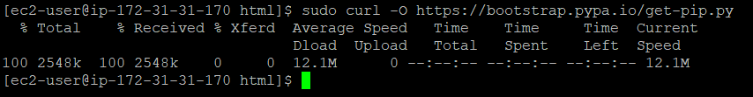

1. Install PIP

***python3 get-pip.py –user***

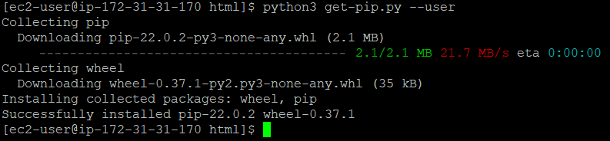

**Install Python Flask & Create a Virtual environment (venv)**

1. Install Flask

***pip install flask***

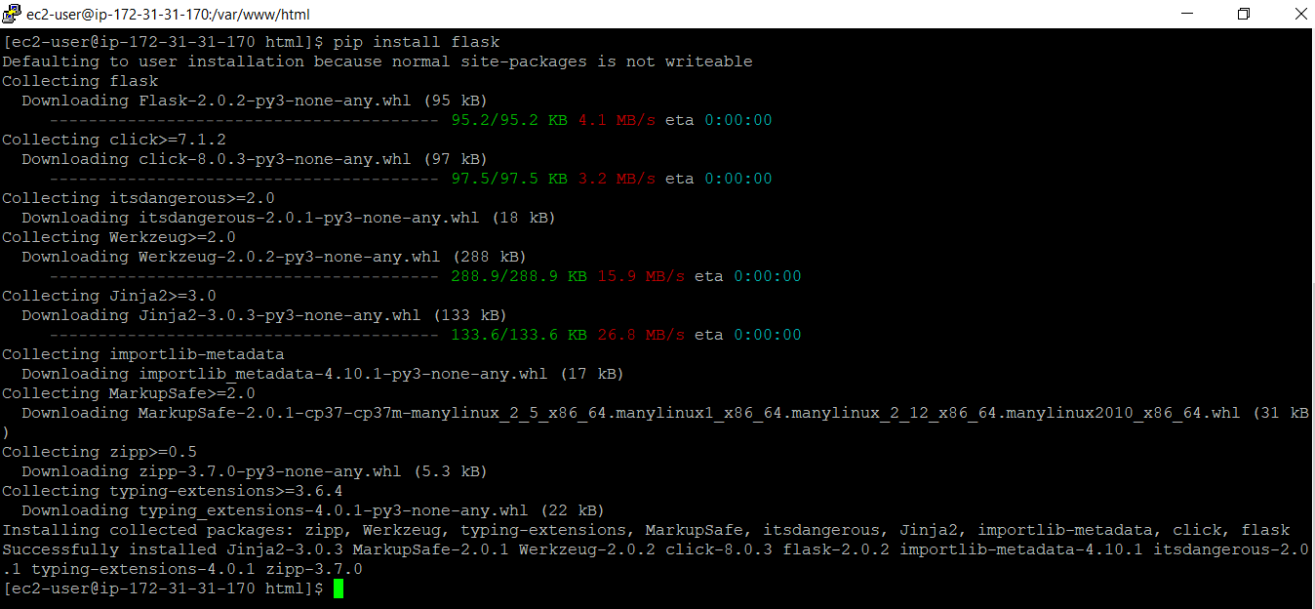

1. Create a virtual environment ‘login_venv’

***sudo python3 -m venv login_venv***

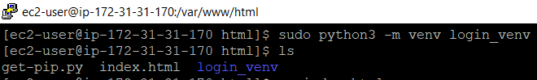

**Create webpage using Flask**

1. Enable Python syntax highlighting on Nano editor

***cp /usr/share/nano/python.nanorc $HOME/.nanorc***

1. Activate Virtual environment

***source login_venv/bin/activate***

1. Create and move into pyflask directory

***sudo mkdir pyflask && cd pyflask***

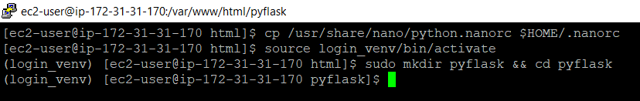

1. Create main.py and other code files and directories inside ‘pyflask’ directory

***sudo nano main.py***



**Creating RDS MySQL Database Instance**

1. Search and Select RDS from the Main search:

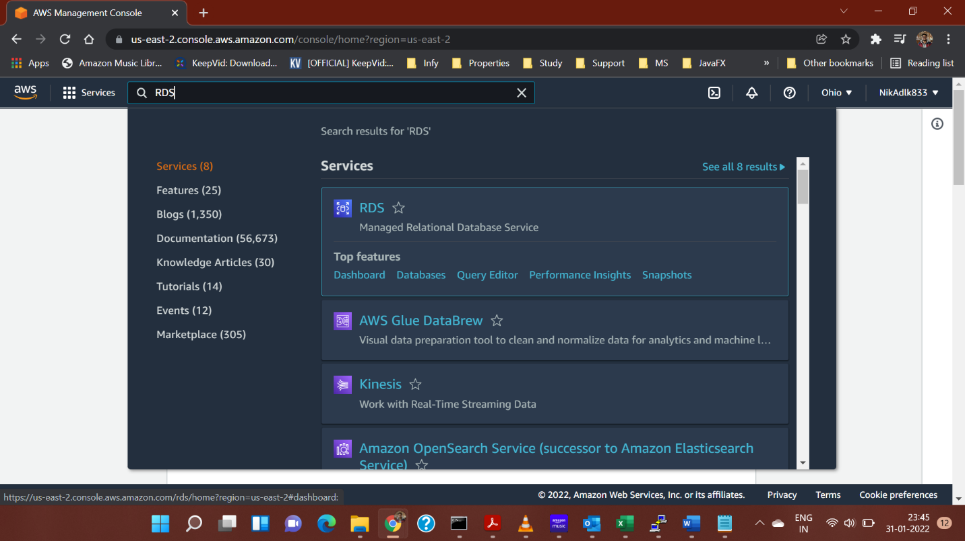

1. On RDS Dashboard, click on ‘Create Database’ button:

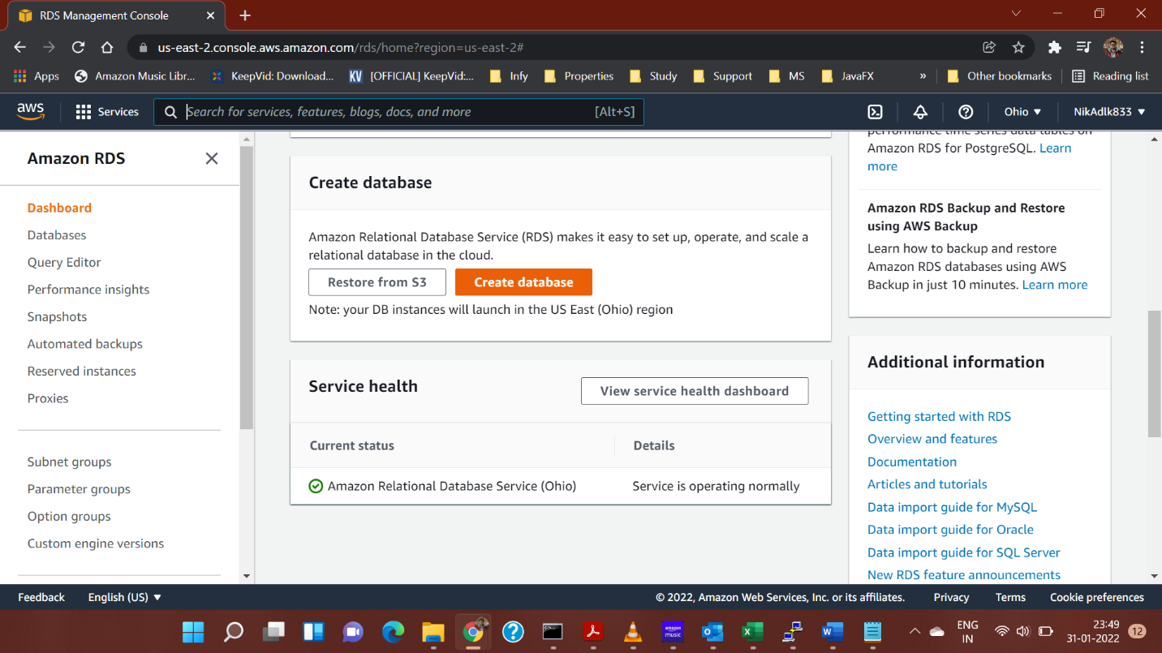

1. On the resulting page, select the ‘Standard Create’ option and select the type of database, you want to make:

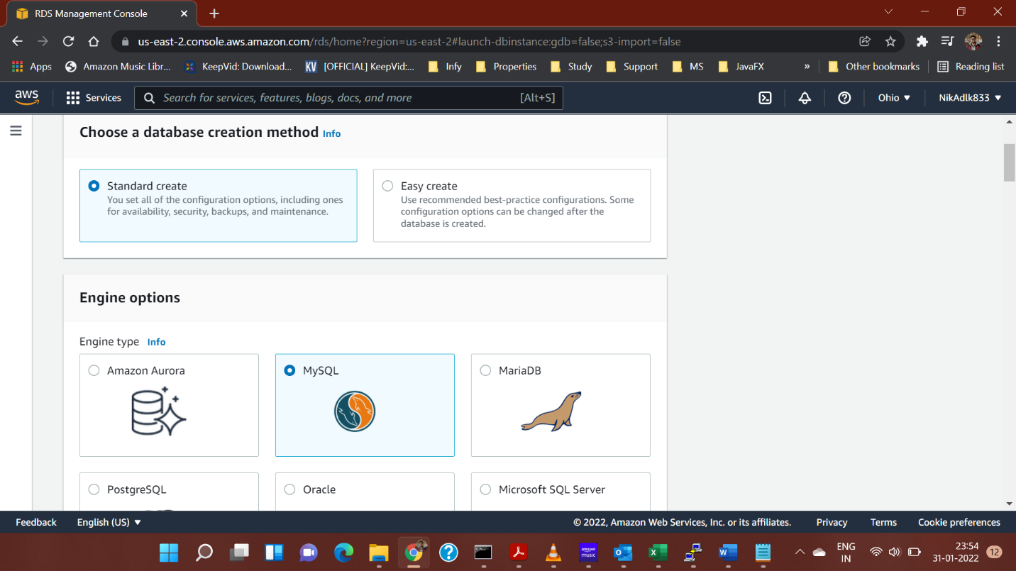

1. Under the **Templates** section, select ‘Free Tier’ option.

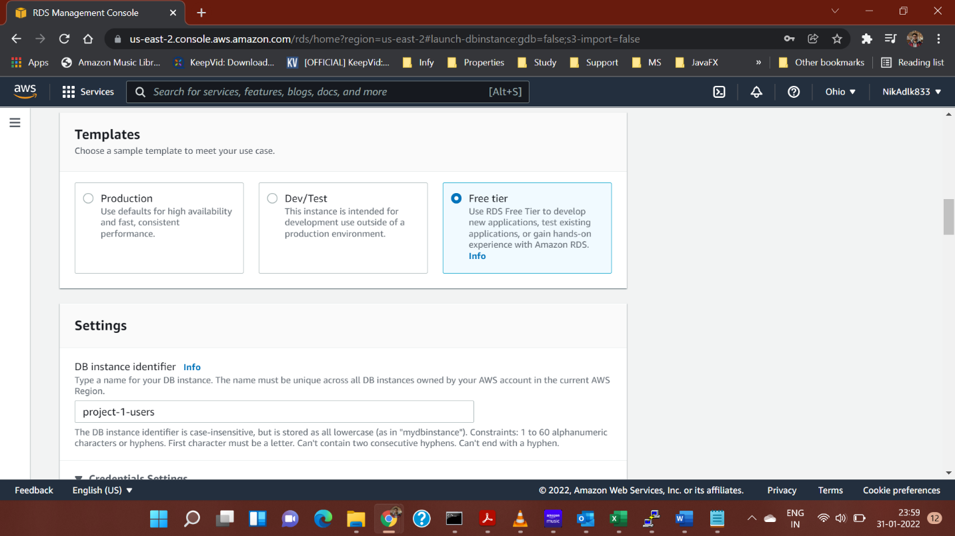

1. Under the **Settings** section, set the DB Instance identifier, master username and password.

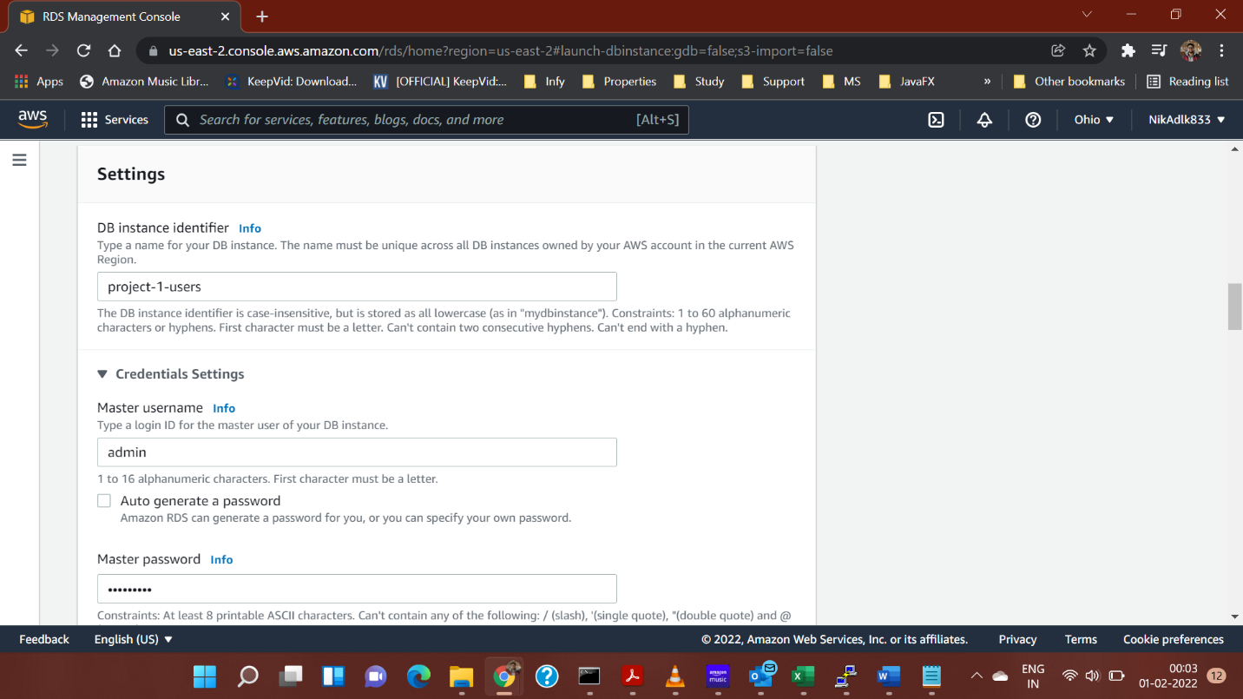

1. Disable Autoscaling, keep all other details the same and then proceed:

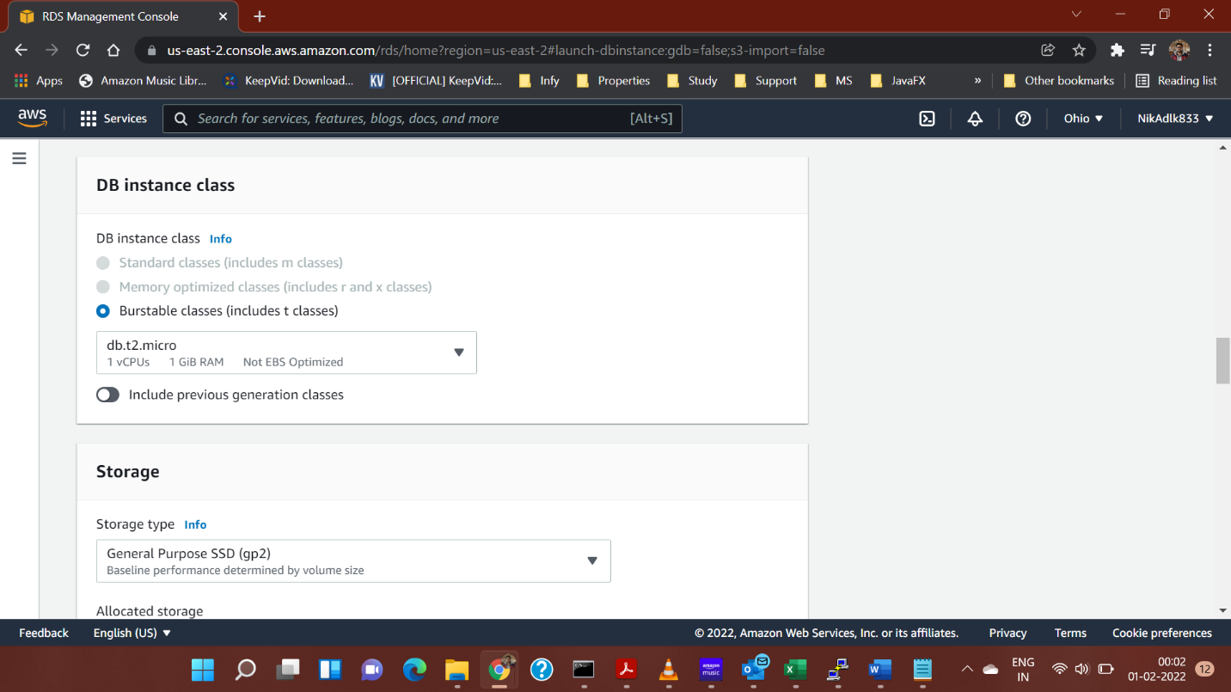

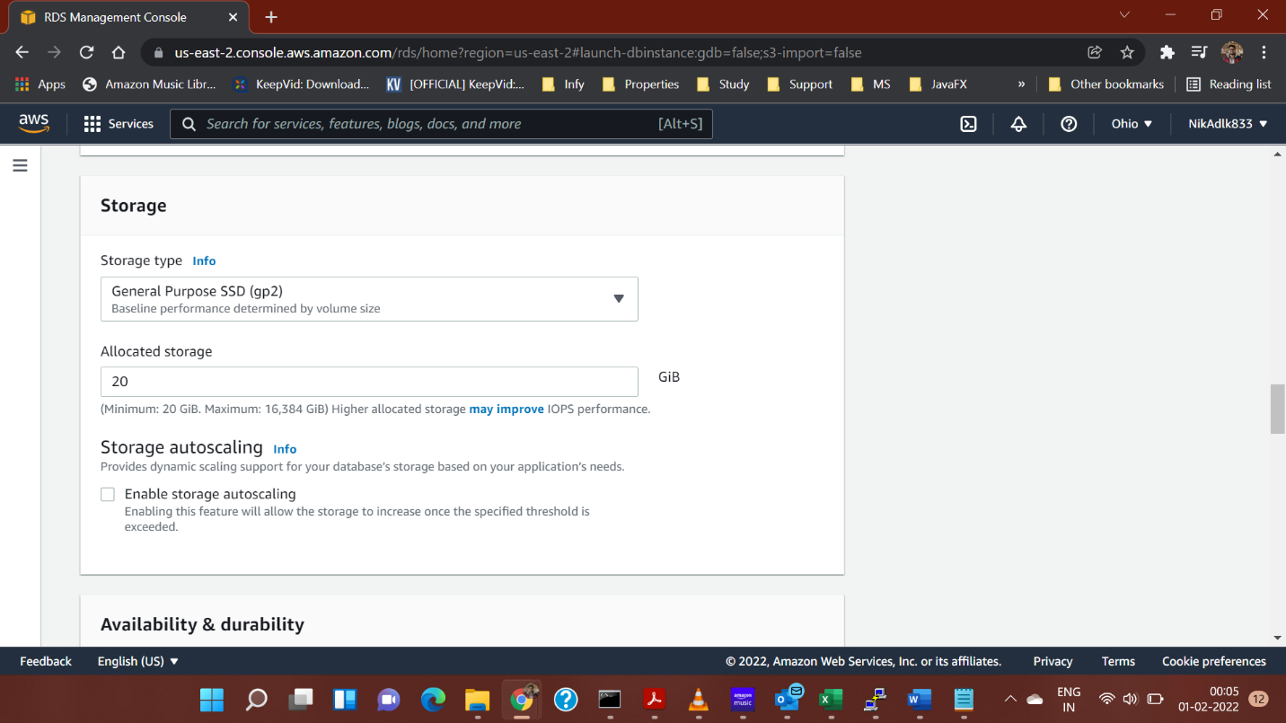

1. Under **Connectivity** Section, make the instance publicly accessible.

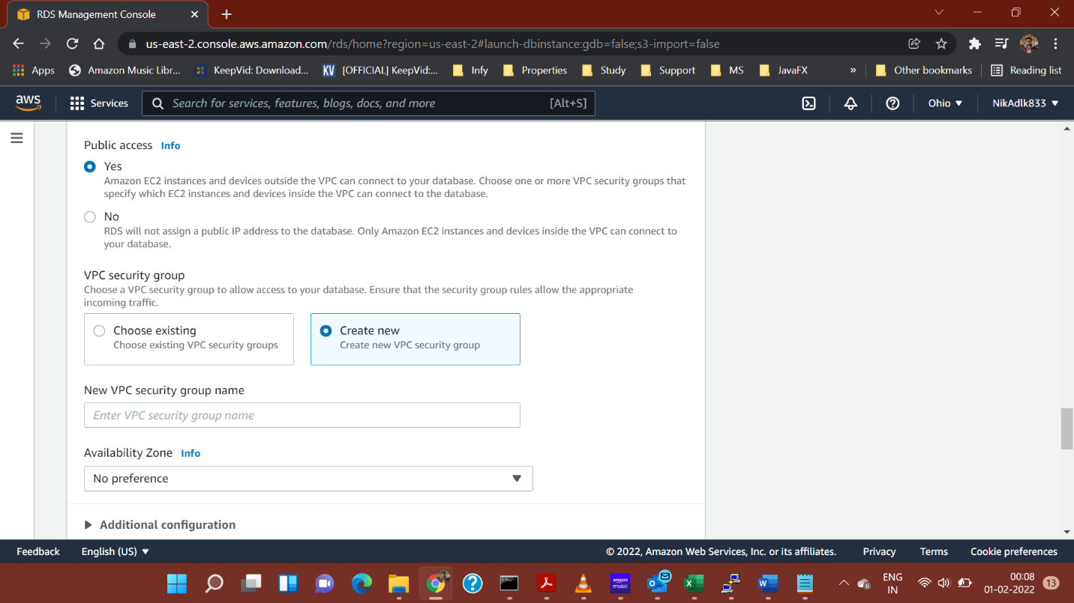

1. Create a new VPC security group.

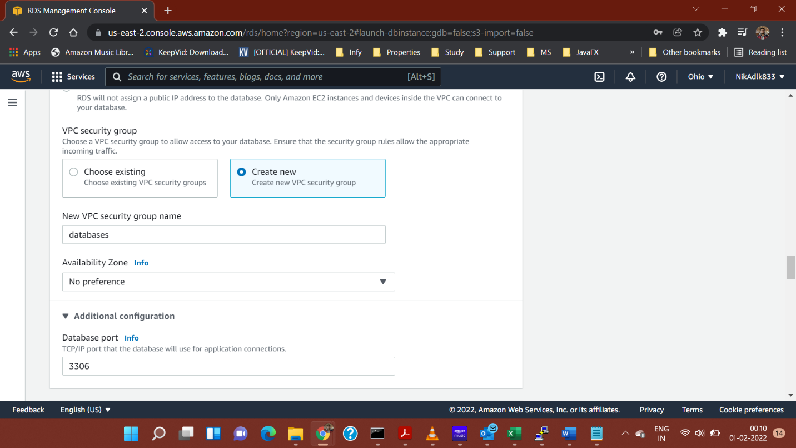

1. Under the Additional Configuration, set the database name. Also disable Automatic Backups.

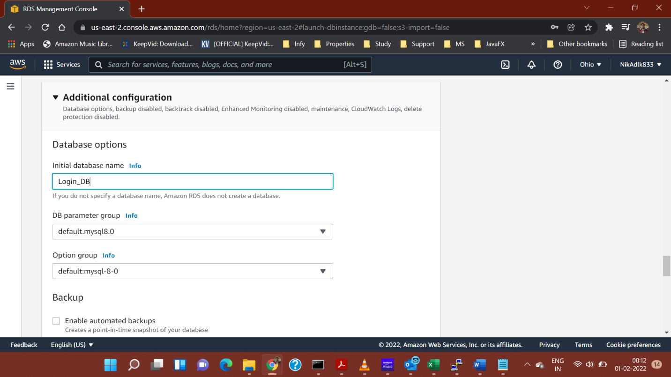

1. Keeping other settings same.

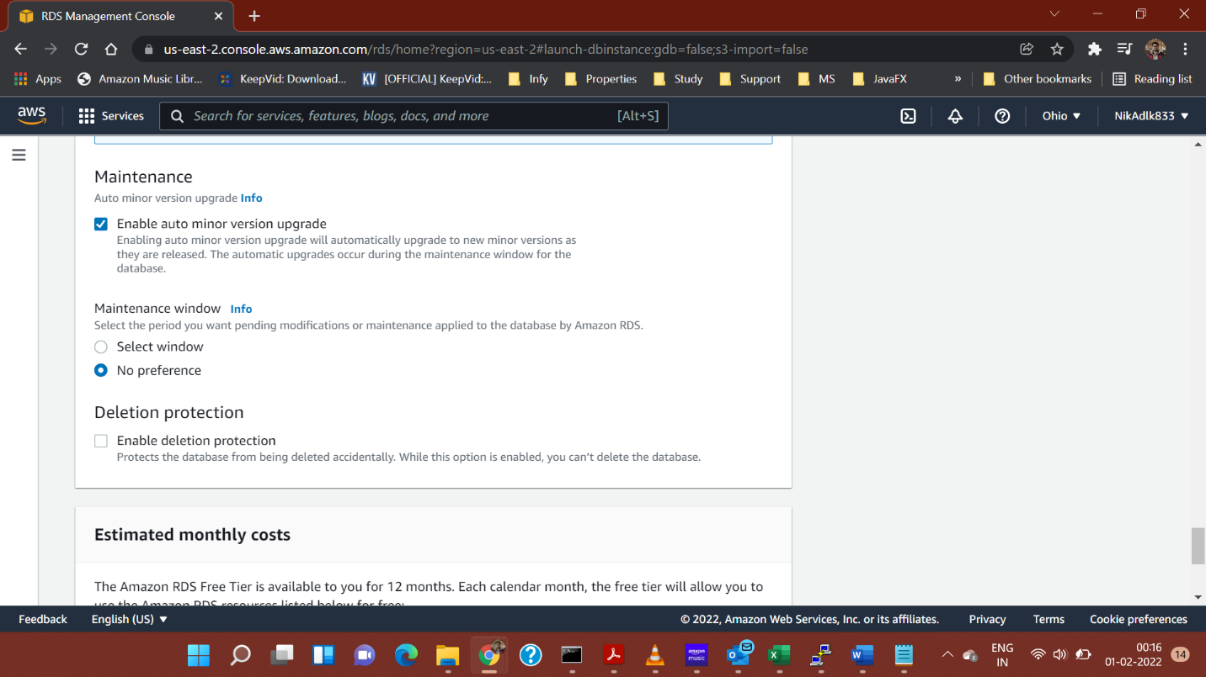

1. Click on ‘**Create Database’** button.

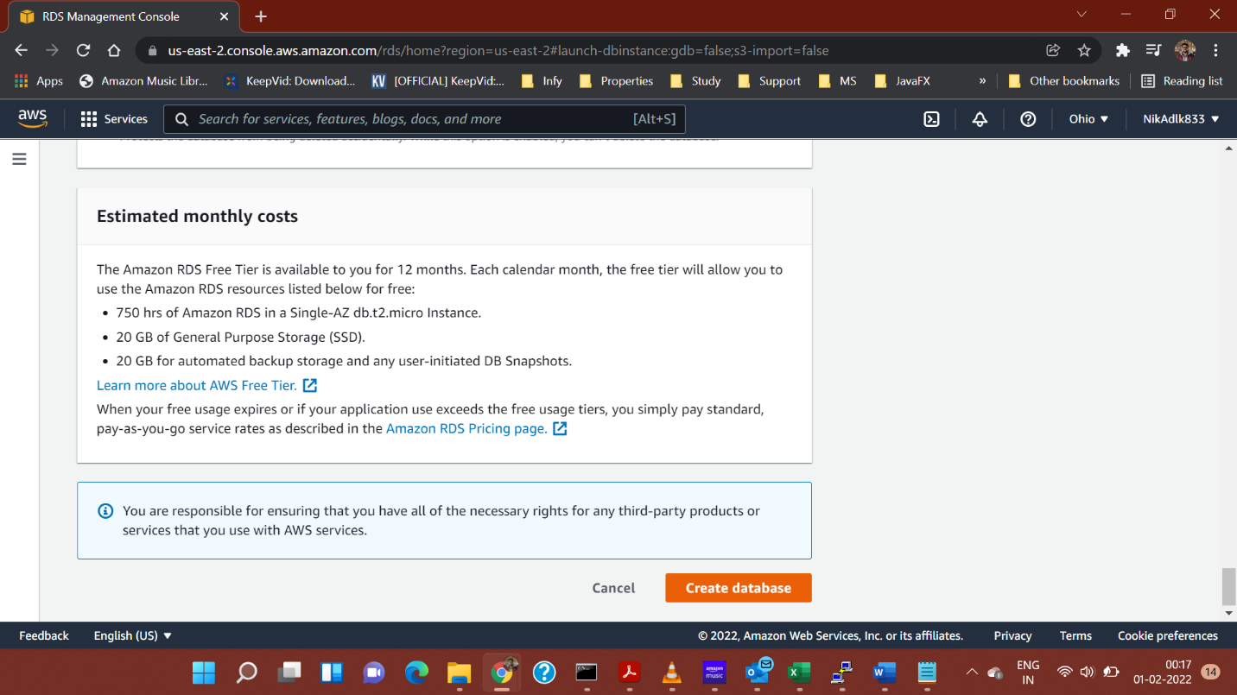

After you have created your database instance, AWS will direct you to your ‘Databases’. You must now create an endpoint for our application to connect to our database.

Setting Endpoint for Created Database:

1. Under the databases, select the database you just created.

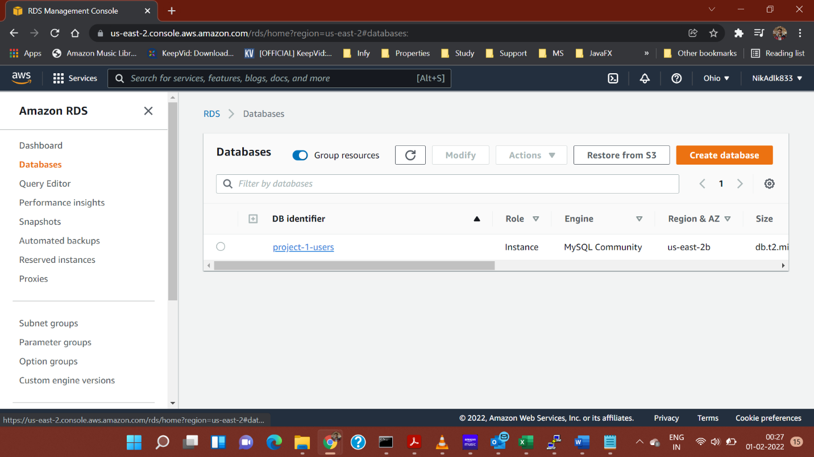

1. Once you have selected your database. Under ‘Connectivity and Security’ tab, click on the VPC security group to manage the group and it’s inbound rules.

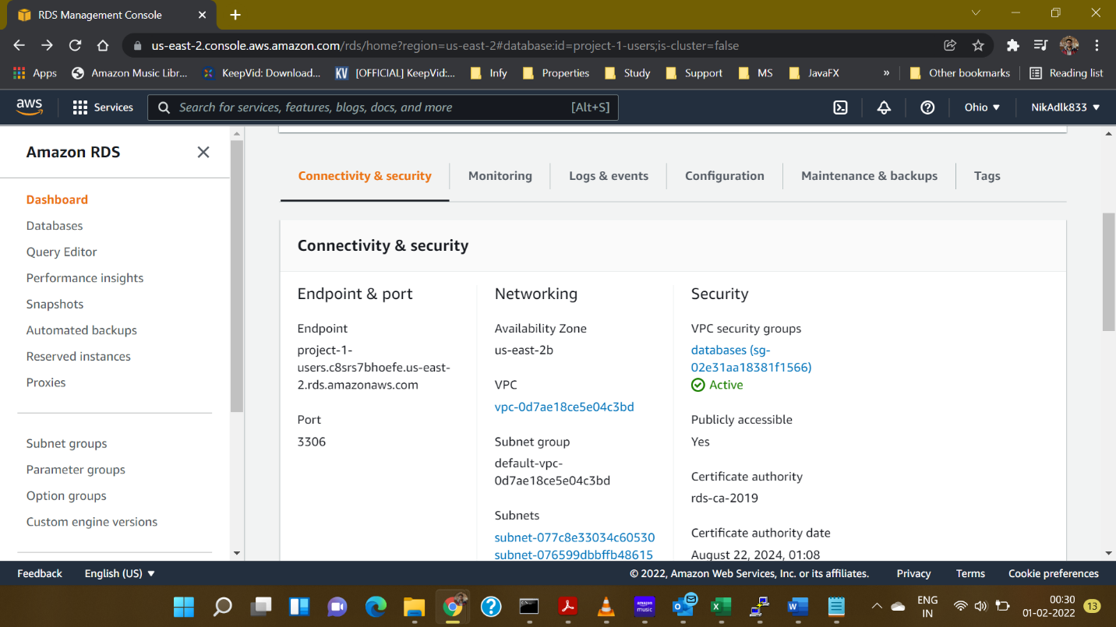

1. Under ‘Inbound rules’ section, click on ‘Edit inbound rules’ button.

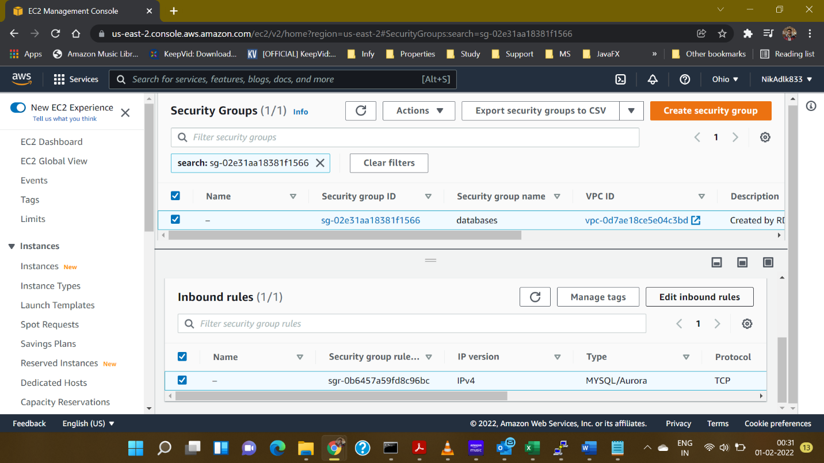

1. Click on ‘Add rule’ button, select the ‘Type’ as HTTP and ‘Source’ as ‘Anywhere IPv4’. Then, click on ‘Save rules’ button.

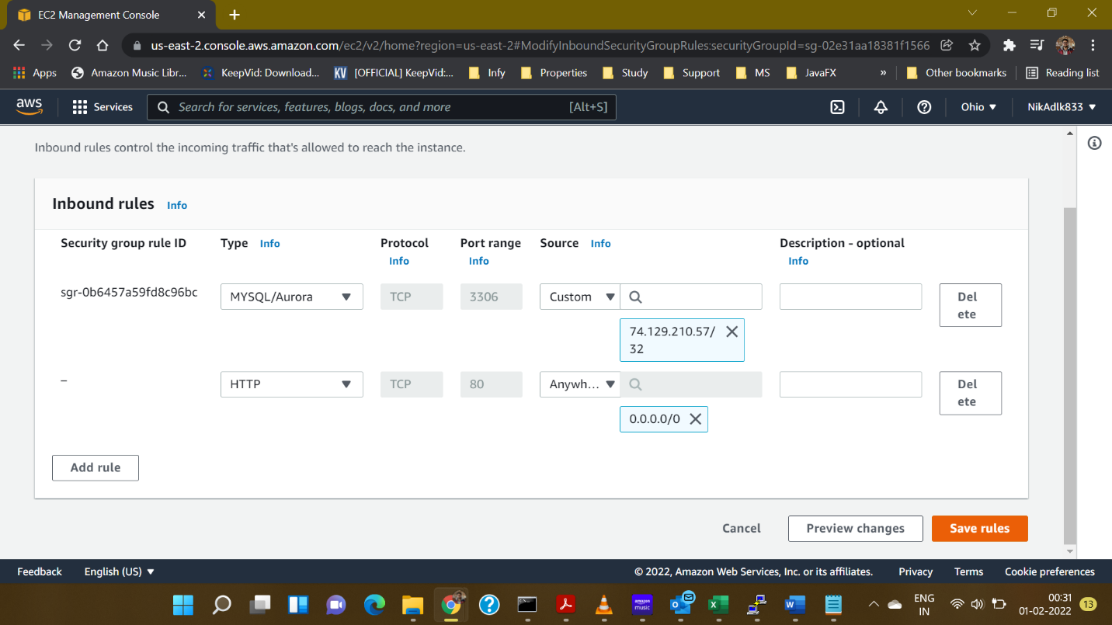

1. Your rule is now saved and now the database will be accessible through HTTP connection.

**Connecting to Database through MySQL Workbench:**

1. Download and install ‘MySQL Workbench’.

**To Store a DB Connection in the Application:**

1. Open ‘MySQL Workbench’ application on your system.
2. Under the ‘Database’ Menu, select ‘Manage Connections’ option.

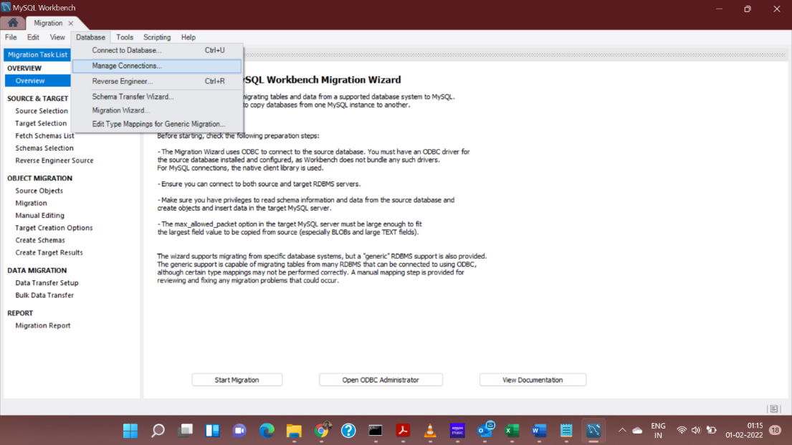

1. Click on ‘New’ button, and then Add the details of your connection by picking the details of the database from your RDS Database instance, and the master username and password, you set while creating the database instance, and then click on ‘Close’.



Hostname

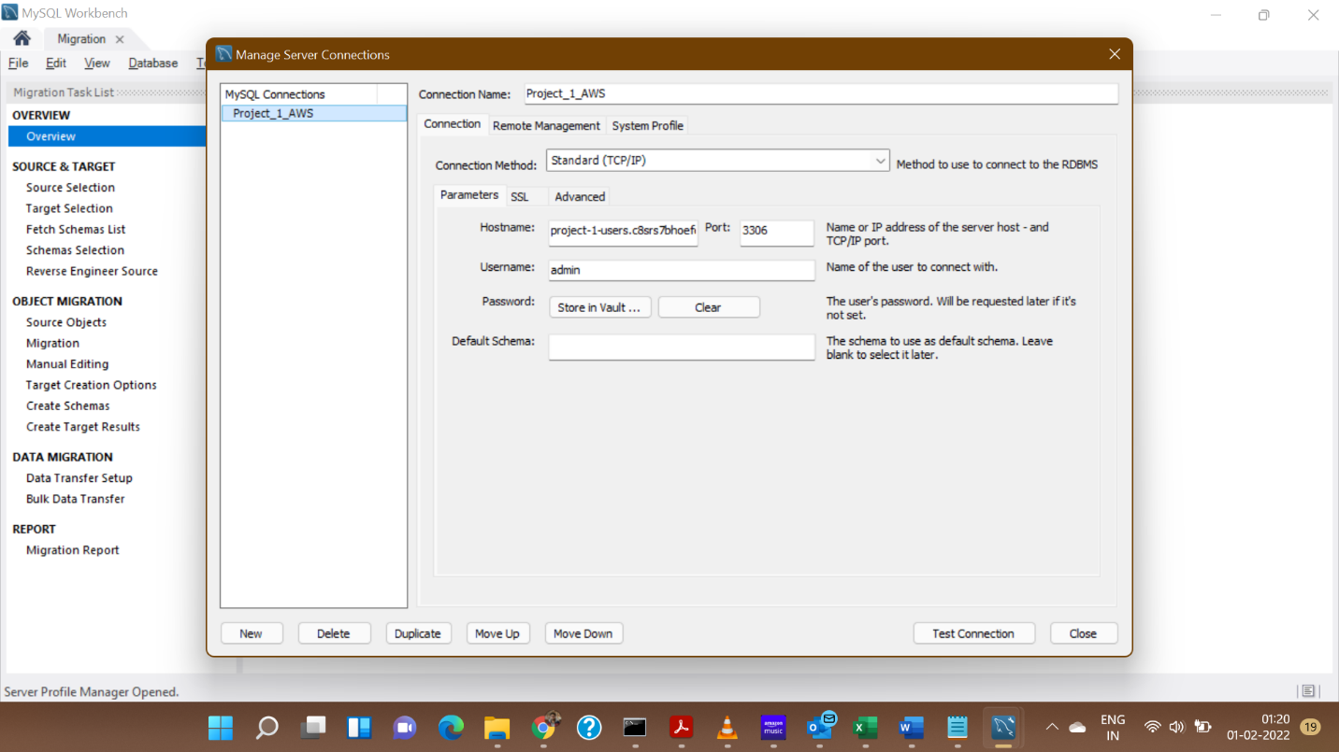

**To Connect to Database:**

1. Open ‘MySQL Workbench’ application on your system.
2. Under the ‘Database’ Menu, select ‘Connect to Database’ option.
3. Either select a stored connection or you may enter the details of your database connection and then click ‘OK’.

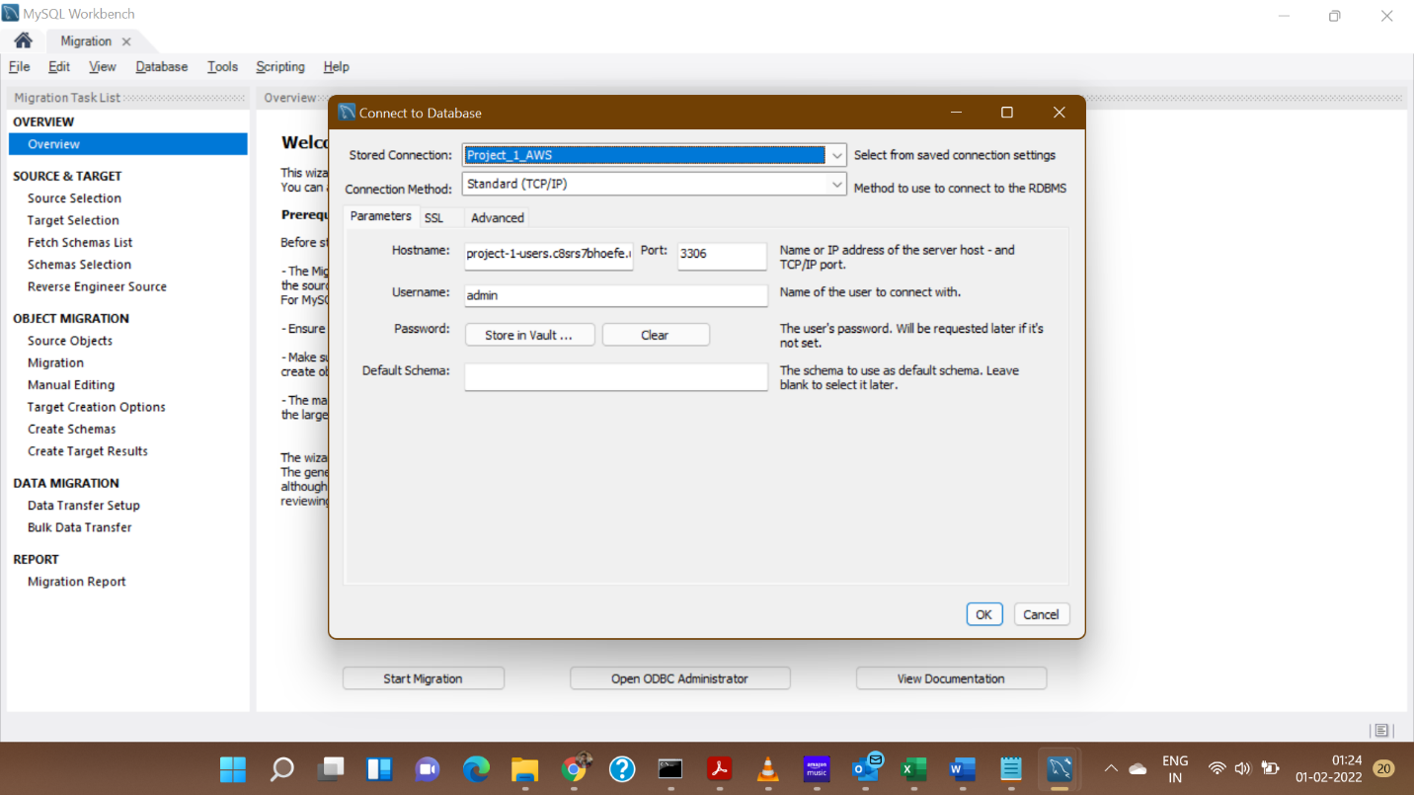

1. You may now be able to see an interface like the following screen.

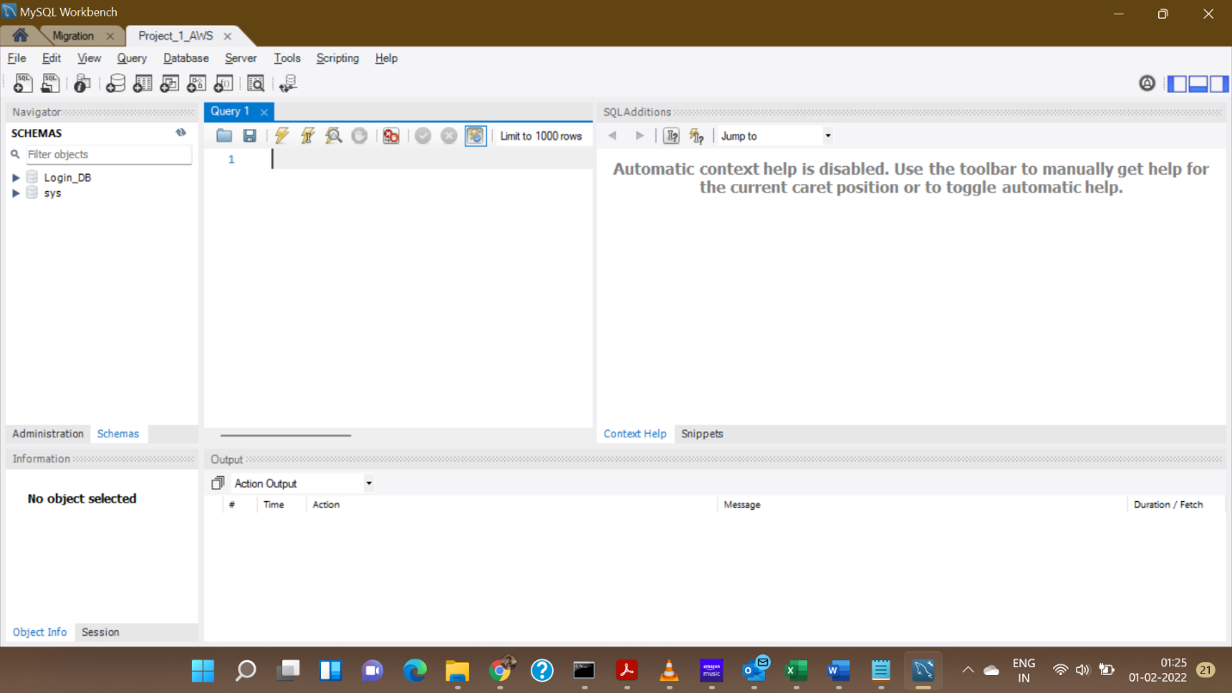

**Creating the Schema for Database:**

1. Open a connection to a database.
2. Execute the following query:

use Login_DB;

CREATE TABLE USER_DETAILS(

FIRSTNAME VARCHAR(200) NOT NULL,

LASTNAME VARCHAR(200) NOT NULL,

USERNAME VARCHAR(50) UNIQUE,

PASSWORD VARCHAR(30) NOT NULL,

EMAIL VARCHAR(50) PRIMARY KEY

);

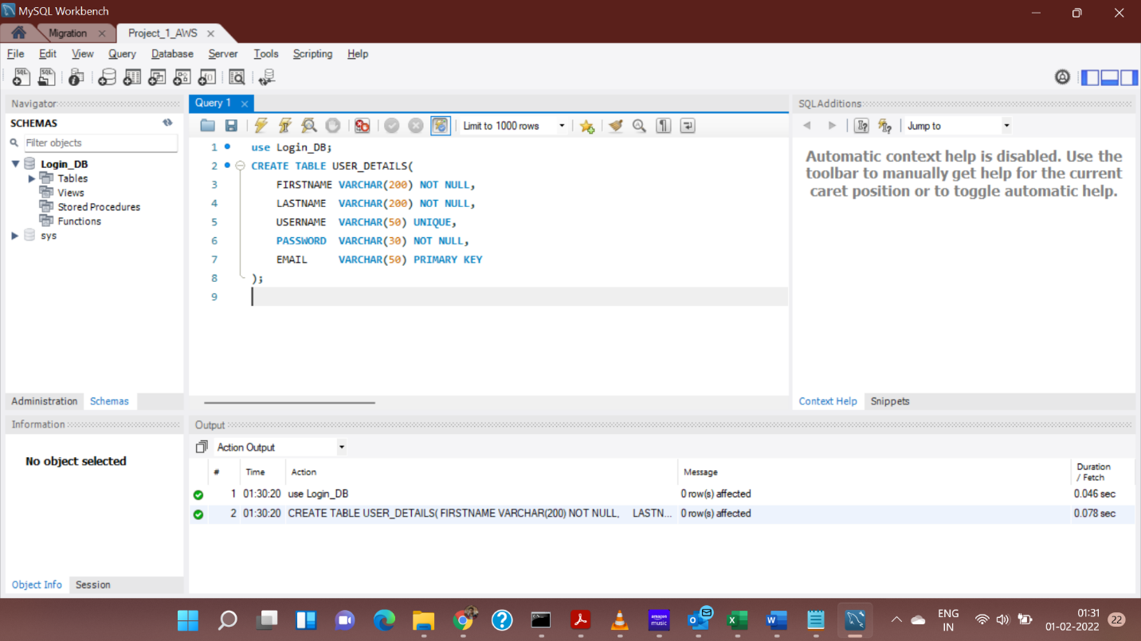

1. This will create the schema, which can now be validated, through the Tree view of the database.

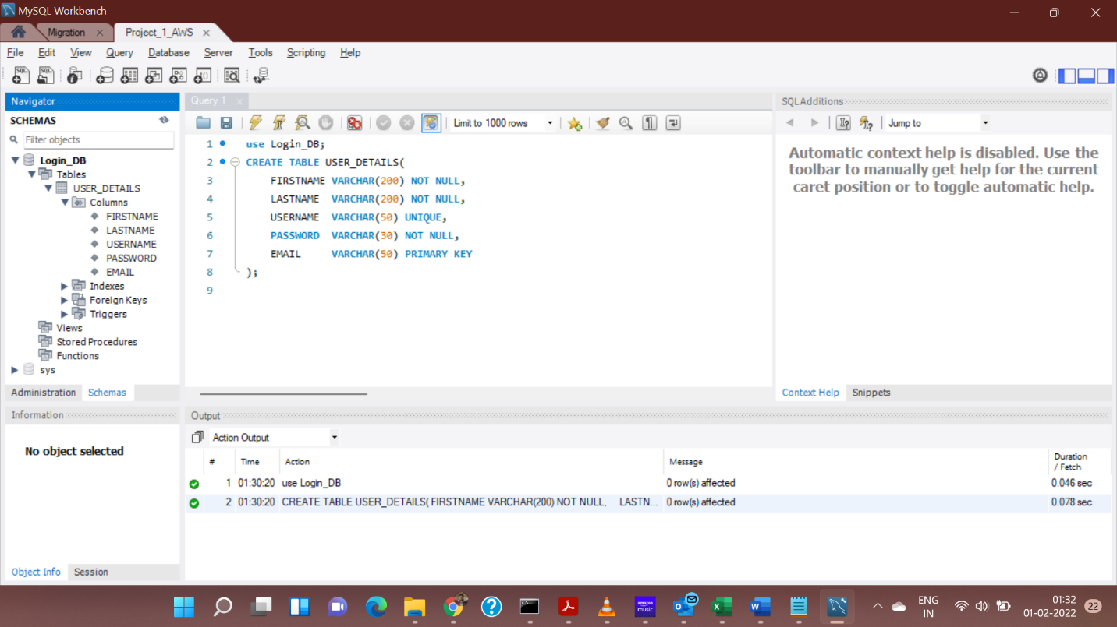

**Export APP and give access**

1. Export Flask app

***export FLASK_APP=main.py***

1. Give access

***flask run --host=0.0.0.0***

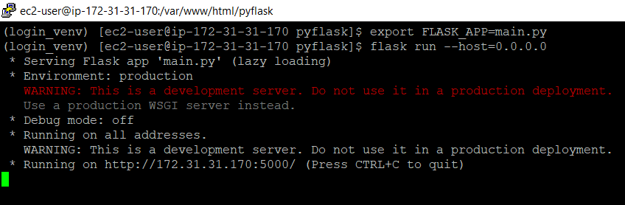

1. View page on browser at **<Public IPV4 Address>:5000**
   1. Open Browser

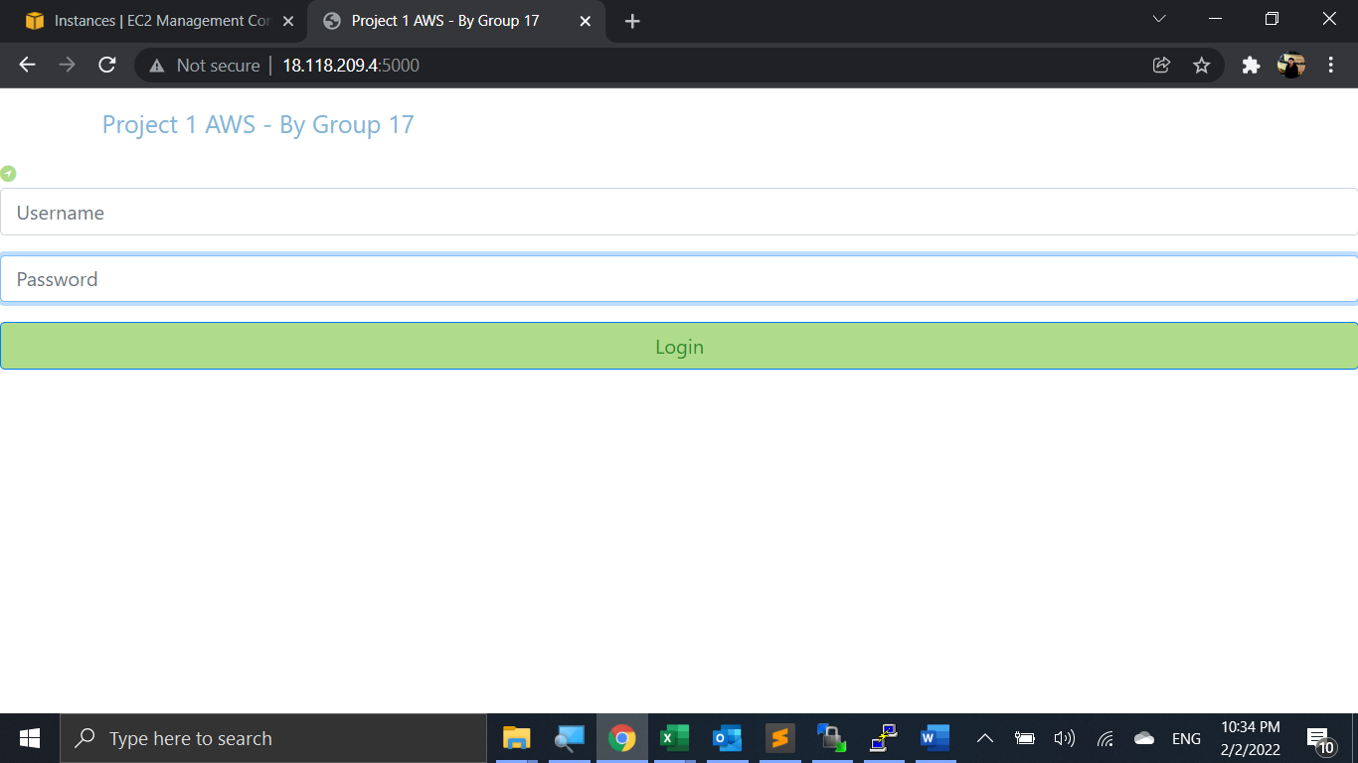

* 1. Enter Username and Password. Click Login

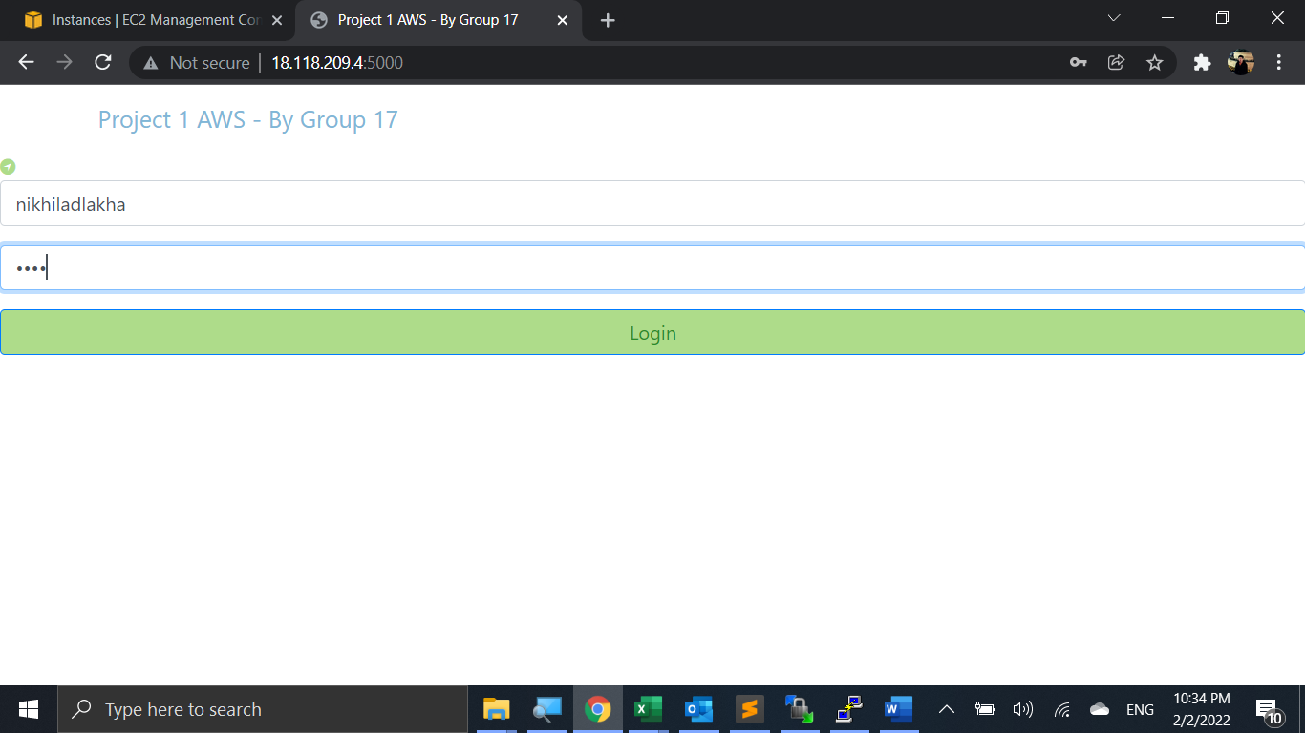

* 1. Since user was not existing create account page was loaded. Enter new user details.

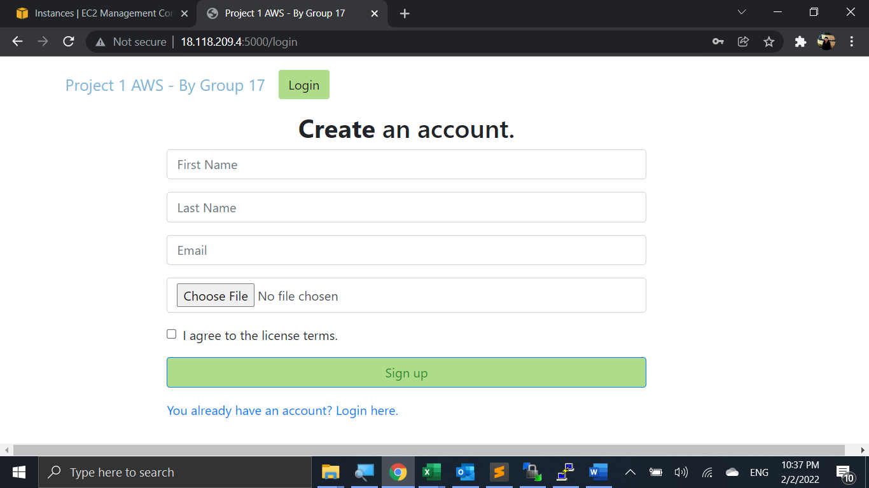

* 1. Choose some text file to upload and agree to license terms.

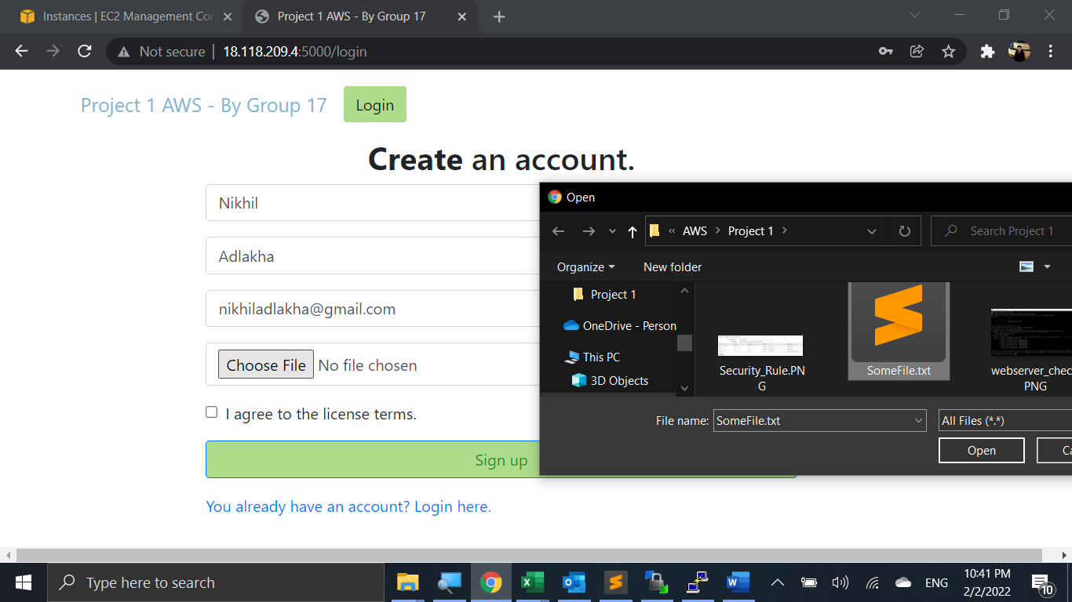

* 1. Click on Sign-Up to create new user.

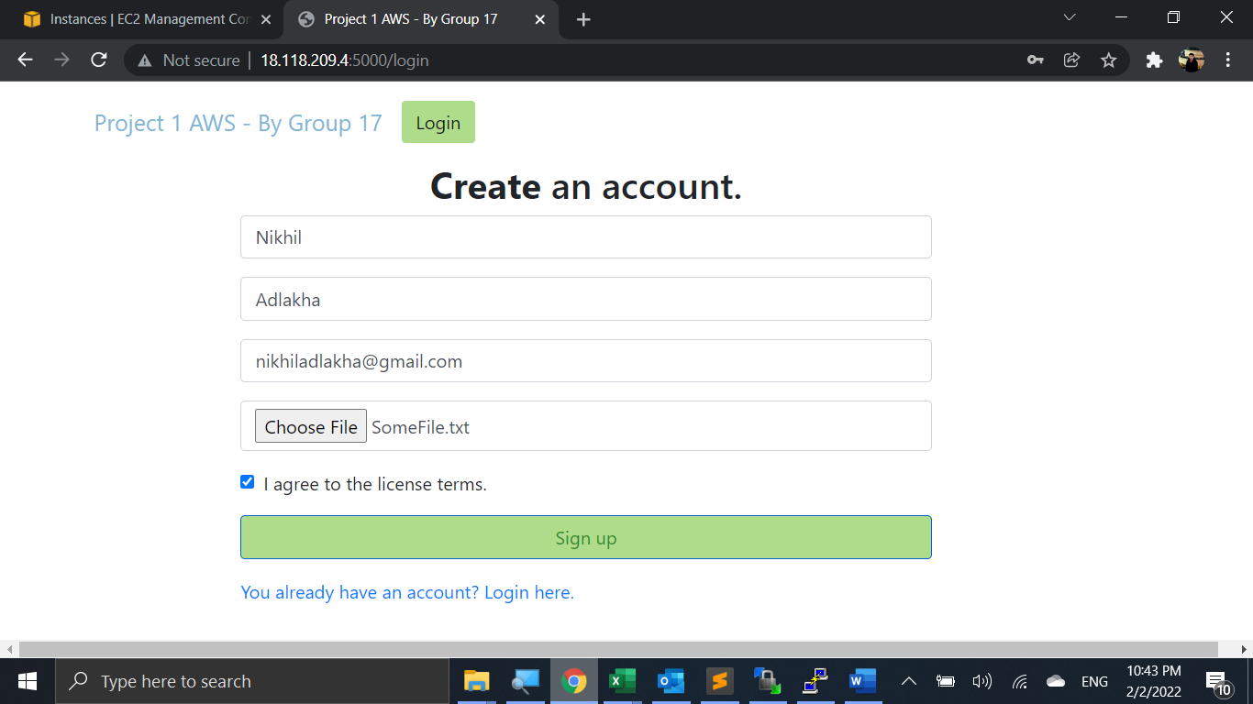

* 1. Enter your user credentials to view your information by clicking Log In. Notice the message new user created.

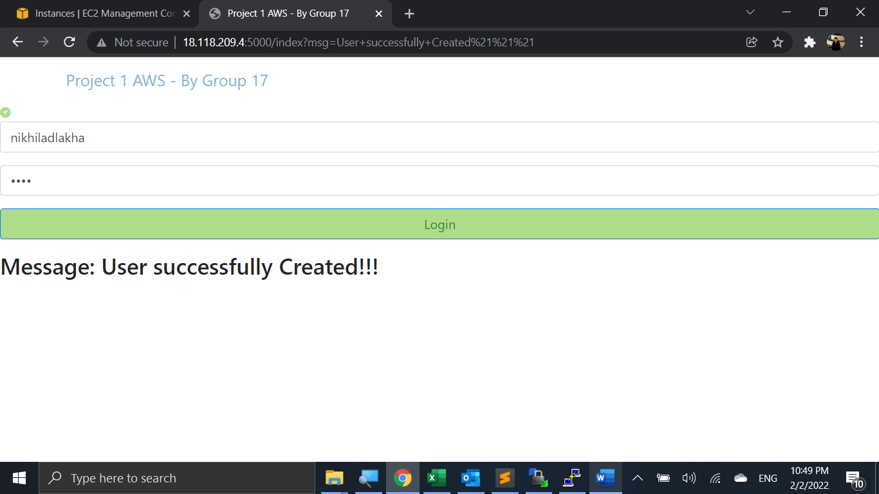

* 1. Check your details and notice word count of your uploaded text file. Now click on the download file link.

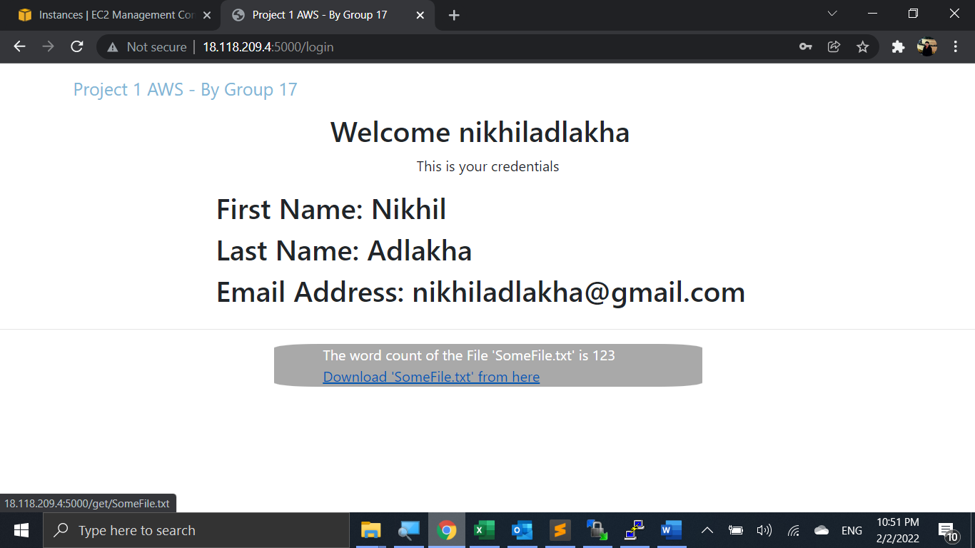

* 1. Now try to enter wrong user credentials and click login.

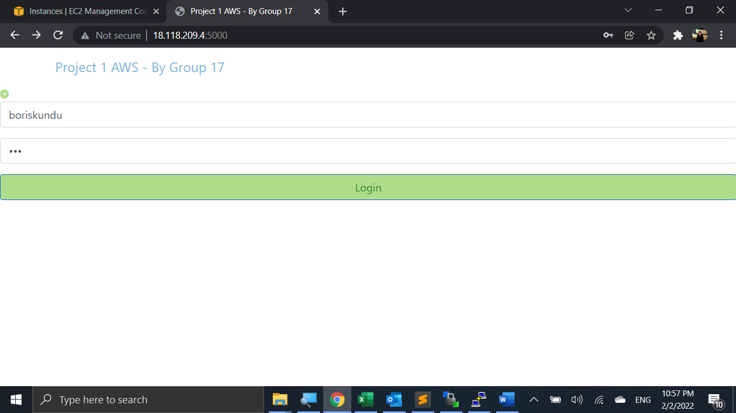

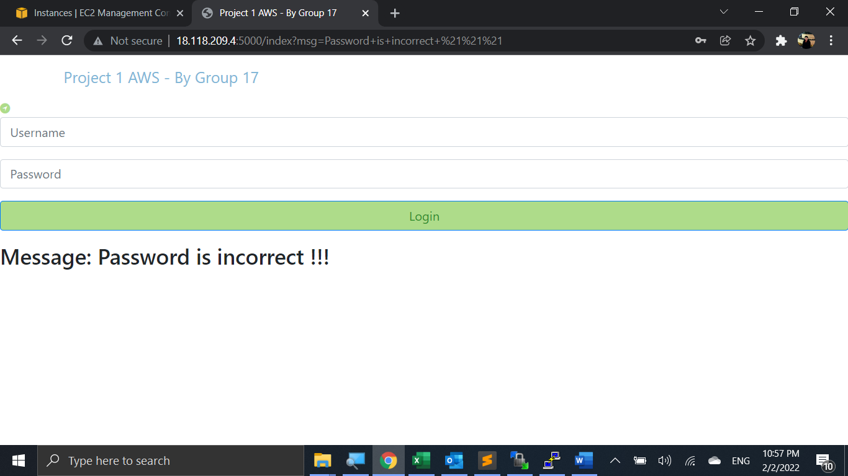

* 1. We can see user details stored below in DB.

